Wrist mounted raspberry pi

In this proposed project we will be constructing a wrist mounted raspberry pi that will be battery powered and have a mini LCD touch screen. The idea behind the project was inspired by the video game Fallout 4 with the item called a Pip-Boy. With smart phones being used more often than laptops in my house, the thought of an arm mounted computer have a few possibilities that I can think of. As for real world applications I can see this being modified for military personnel to have the ability to send or receive encrypted messages, blueprint or other mission vial information; I can also see where this can be used for potential onsite hacking/cracking. Obviously the potential of this idea can be used for both good and bad my main purpose is to figure if it can be done and what skills are needed.

Below are two pictures where the idea was used in an entertainment capacity.

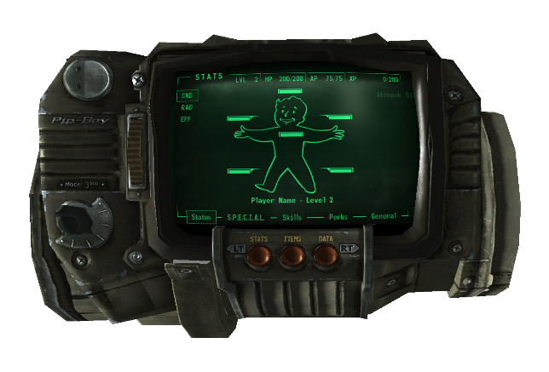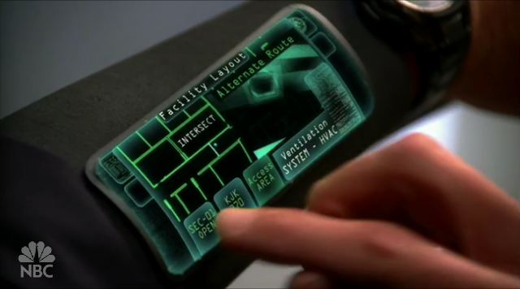

This Is the Pip Boy from Fallout 4 This is the Wrist computer from the TV show Chuck

As we can see the concept of having computers attached to our arms is nothing new and is growing in popularity with Smart watches and even items like the Fitbit.

Projected Parts needed:

* 3.5-4.5 inch touch screen that can connect to the raspberry pi
* Raspberry pi
* Min 8 GB micro sd card
* battery
* Battery booster/charger
* Switch to turn the power on or off
* Some sort of mounting system to the arm, either 3d printed or crafted in some other way

With this project my main concern will be power supply. Can the raspberry pi with a touch screen be powered up via battery that is easily haul-able or will a supply like a car battery be needed? What sort of extra electronics will be needed to hook the battery up so the power supply can be considered stable? These are just a few questions that will be explored with this project.

<https://www.makersspark.com/single-post/2013/05/01/Pipboy-3000-Arm-Mounted-Computer>

<http://www.instructables.com/id/Pip-boy-3000-Mark-II/>

<https://blog.adafruit.com/2014/12/03/pipboy-3000-arm-mounted-computer-wearablewednesday/>

<http://www.instructables.com/id/Portable-Wrist-Mounted-Raspberry-Pi/>